**Technical report:**

***Table: 1***

*Shows the accuracy of the sensors*

The project “**controlled infant incubator**” basically provides the optimal factors that keep the infant safe and control the factors effect on it.

|  |  |
| --- | --- |
| **sensor** | **error** |
| DHT 11 | $±$**1** Celsius for temperature and $±$**4 Rh** for humidity |
| Mic sensor | $±$ 3 dB |
| Air quality and dust | $± 0.15$ mg/ $m^{3}$. |

**First, the hardware:**

The system consists of 3 sensors that is able to measure 4 parameters in which DHT11 that

measure the temperature and humidity, Mic senor that measures the noise level and make sure not be exceeds than 85 db, and air quality and dust sensor that measures the air quality index and smoke in the air and make sure that index does not exceed above 50 (1 mg/m^3).

**Figure:** **1**

Shows the connection of the circuit

All these sensors are connected to ESP 32 that work as the microcontroller in the circuit and send data wirelessly by its imbedded Wi-Fi-module.

In addition to using 150-ohm resistor and 150 of 25V capacitor in the circuit to maintain the voltage.

Furthermore, buzzer sensor was impeded in the circuit to make alert on reaching to the threshold.

**Power supply of the system:**

3 lithium-ion batteries (4 Volt each one) will be used to power the system and recharge it again using an 18V solar panel.

**Figure: 2**

Shows the dashboard

**The connection of the components in the circuit:**

In **DHT11** sensor, the VCC pin was connected to a 150-ohm resistor, which is connected to the 3V3 pin of the ESP32. The sensor's data pin is connected to the D33 pin of the ESP32, and the sensor's GND pin is connected to the ESP32's GND pin.

For a **Mic sensor**, the positive terminal is connected to the 3V3 pin of the ESP32, the data pin is connected to the D35 pin of the ESP32, and the GND pin is connected to the GND pin of the ESP32.

While the **Dust and Air quality sensor**, the Red wire of the sensor is connected to the 3V3 pin of the ESP32. The black wire of the sensor is connected to the D34 pin. The yellow and blue wires of the sensor are connected to the GND pin of the ESP32. The green wire of the sensor is connected to the D23 pin of the ESP32. The white wire of the sensor is connected to a 150-ohm resistor and 150 of 25V capacitor.

**Secondly, the software:**

**Figure: 3** shows data stored in Google sheets

* 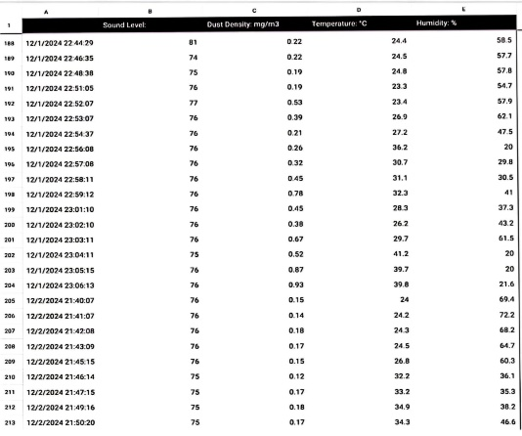**The dashboard:**

A live dashboard website is connected to the ESP32 that shows real time data and represent each parameter on a separated graph to be able to watch it, moreover the graph is in green color in case of the normal setup while on approaching to the threshold the color become yellow to prevent an expected problem at the beginning and on the threshold the color become red as an indicator of an error.

* **Storage on google sheets:** All these data have been stored in google sheets that update and store the data every one minute and be able to store the data for years without limit, in addition to the ability of reaching to the data on any device connected to the internet and upload the pervious data easily.